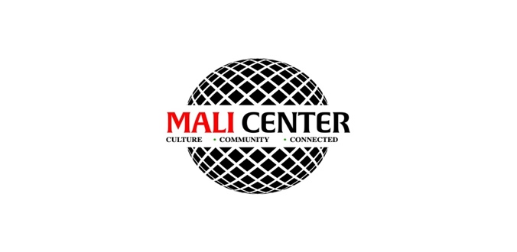
MEDIA RELEASE FORM

I am willingly having my picture taken, my voice recorded or agreeing to appear in video footage and grant The F.I.T. Lab, The Mali Center, TMREIT, LLC, Rooted Philanthropic and its representatives and affiliates permission to use my picture, voice, video footage, name, image, likeness and physical surroundings without restriction for the purposes of promoting the The F.I.T-COMM Challenge or other projects, whether they be print, projection, internet, website, video, social media or any future media market.

I expressly release The F.I.T. Lab, The Mali Center, TMREIT, LLC, Rooted Philanthropic its representatives or any institution transmitting, or exhibiting my picture, name voice, image, likeness or video footage from any claims arising from such use or distribution.

I agree to be fully responsible for my own participation and hold The F.I.T. Lab, The Mali Center, TMREIT, LLC, Rooted Philanthropic or its representatives and affiliates harmless from any liability or loss of expense arising from the use of my picture, voice, name, image, likeness or video footage. I also consent to the use of my voice, picture, name, image, likeness or video footage and other information about me for promotional, publicity, or organizational purposes.

______________________________________________________ _________________________________
Signature Date



